1. Select any 5 capitals of states in India and enter them in a file named *capitals1*. Choose 5 more capitals and enter them in a file named *capitals2*. Choose 5 more capitals and enter them in a file named *capitals3*. Concatenate all 3 files and redirect the output to a file named *capitals*.

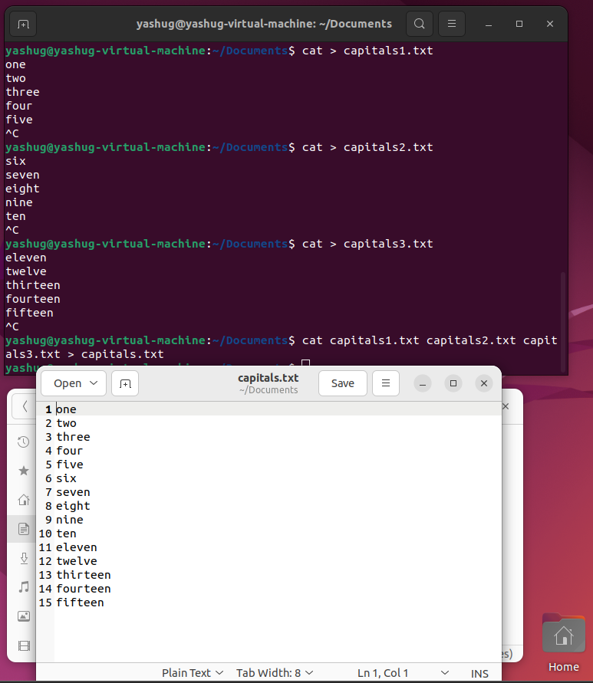

1. Concatenate the file *capitals2* at the end of file *capitals*.

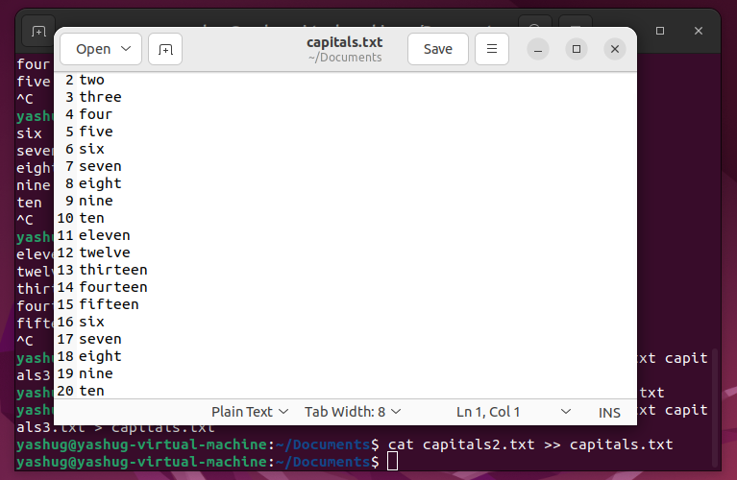

1. Redirect the file *capitals* as an input to the command “wc –l”.



1. Give read and write permissions to all users for the file *capitals*.

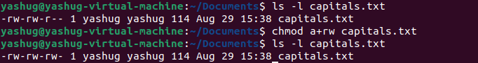

1. Give read permissions only to the owner of the file *capitals*. Open the file, make some changes and try to save it. What happens ?

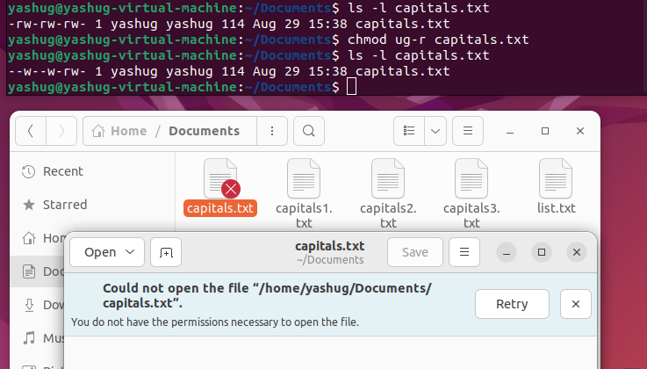

1. Create an alias to concatenate the 3 files *capitals1*, *capitals2*, *capitals3* and redirect the output to a file named *capitals*. Activate the alias and make it run.

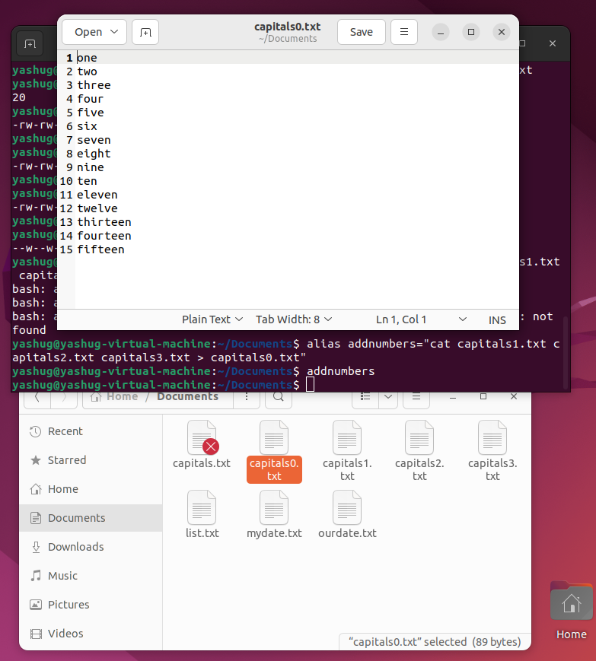

1. What are the environment variables PATH, HOME and TERM set to on your terminal ?

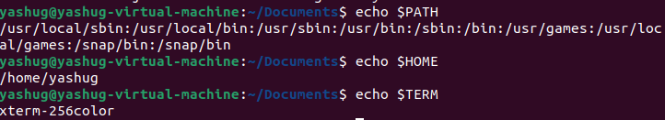

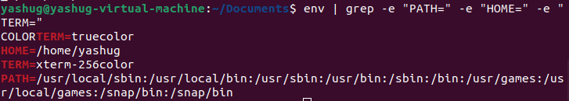

1. Find out the number of times the string “the” appears in the file *mydate*.

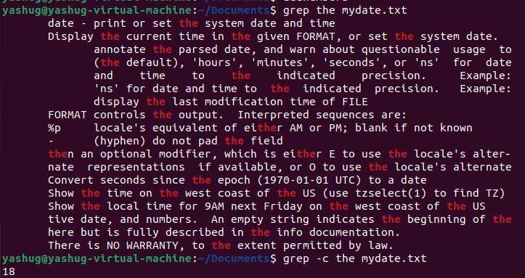

1. Find out the line numbers on which the string “date” exists in *mydate*.

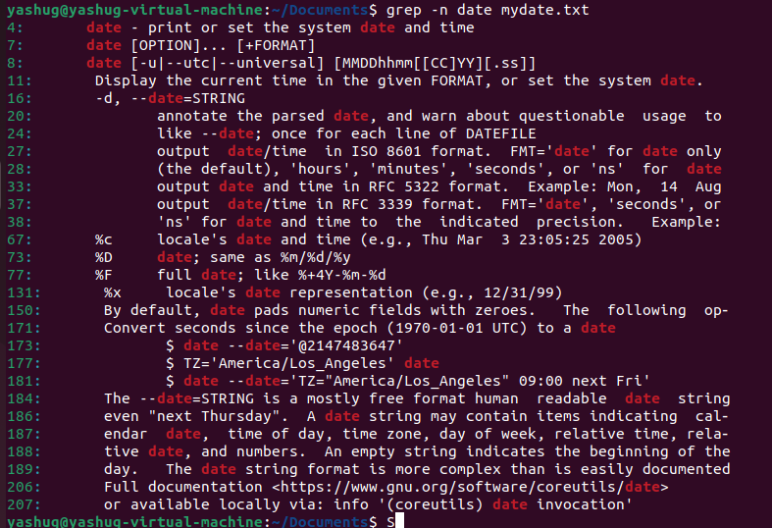

1. Print all lines of *mydate* except those that have the letter “i” in them.

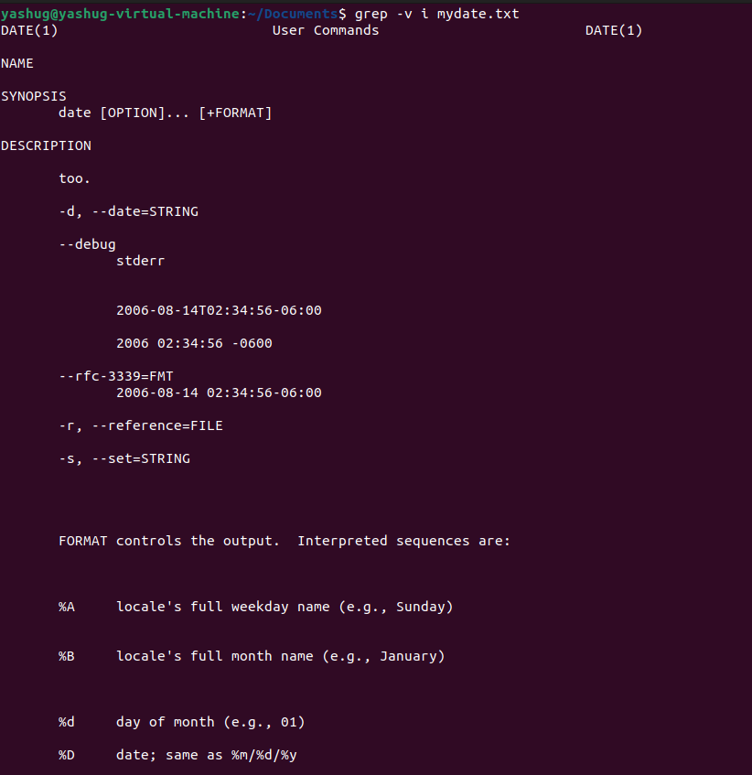

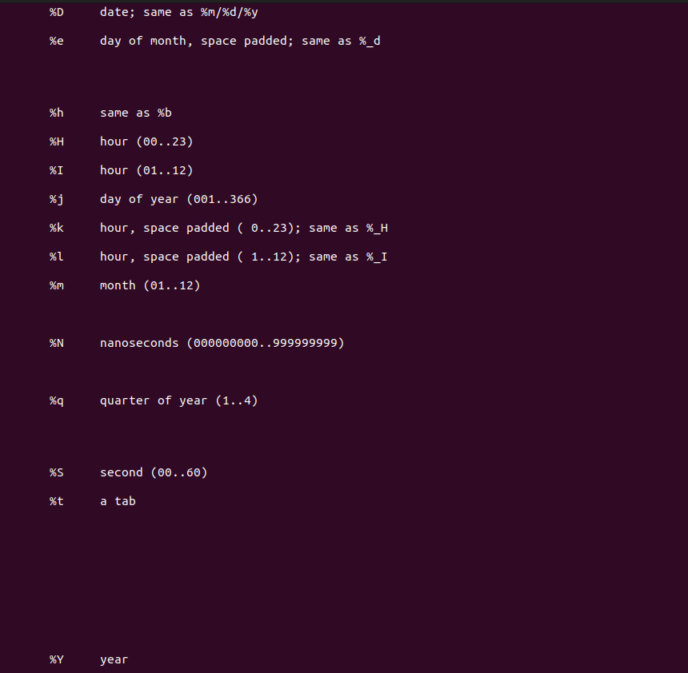

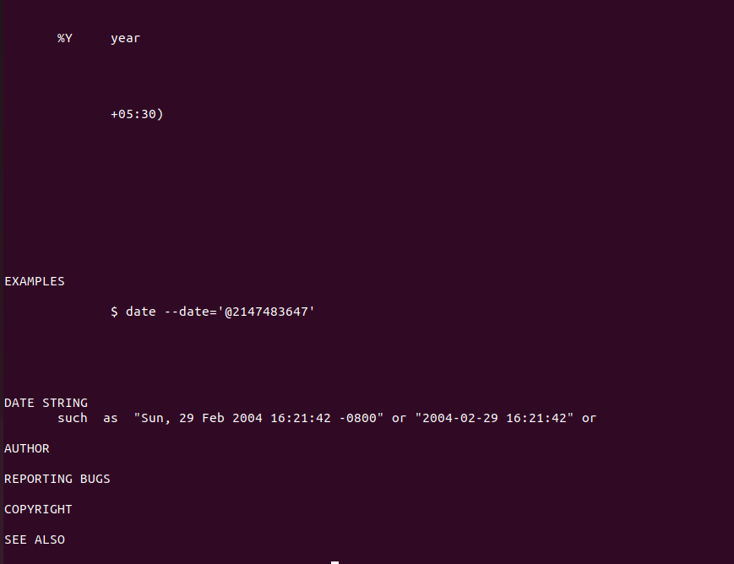

1. List 5 states in north east India in a file *mystates*. List their corresponding capitals in a file *mycapitals*. Use the *paste* command to join the 2 files.

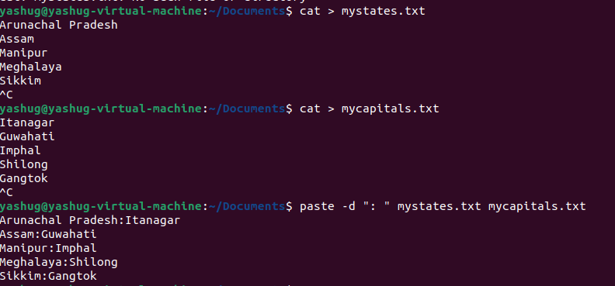

1. Use the *cut* command to print the 1st and 3rd columns of the /etc/passwd file for all students in this class.

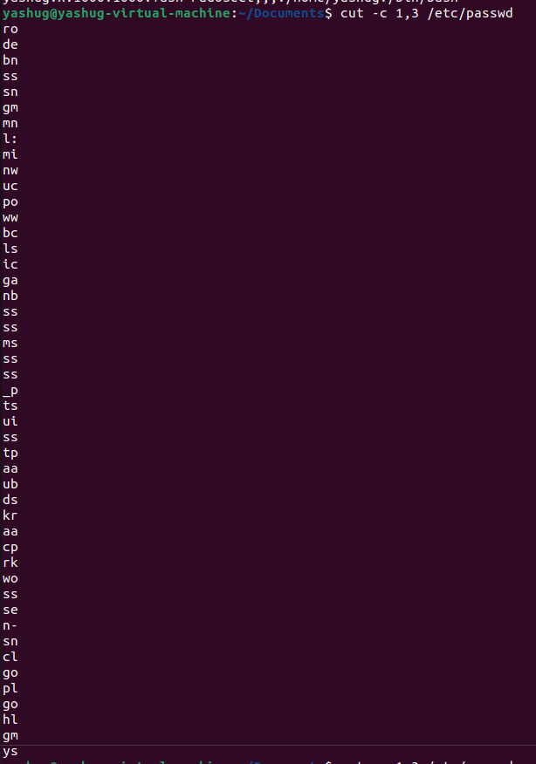

1. Count the number of people logged in and also trap the users in a file using the *tee* command.

